Fr. Pat P. Villasanta, SDB (FIN Province) 12 June 2011
submitted to: Fr. Alfred Maravilla SDB e-mail:alfredsdb@gmail.com; Fr. Joseph Phuoc Nguyen SDB e-mail:phuocsdb@yahoo.com

Study Days on the Salesian Mission and the Initial Proclamation of Christ in the Three-fold Context of East Asia
(venue: Sampran, Thailand on 14 August till 18 August, 2011)

- In the place where you live and work: What is your experience regarding the initial proclamation of Jesus to young people and adults?
The Context:
I am currently assigned in a new Salesian Presence at the the Southville 7 (SV-7) in Calauan, Laguna- Philippines. It is a 107-hectare community owned by the National Housing Authority (NHA) Office of the President. This is a resettlement site of more than 6000 families who came from various parts of Metro Manila slums and a big bulk of informal settlers along the River Pasig. The place is projected with a population of 10,000 families or 50,000 to 80,000 relocatees at the end of the year 2011. This, indeed as Fr. Salvador Pablo would put it, is a ‘social volcano’ where various crimes, vices and other social issues and concerns can move stealthily, if without proper education and evangelization programs.

The FIN Salesians were invited by the Ayala Corporation in February 2010 to establish a presence for this new community emerging in Calauan Laguna. The deliberation took place in the Provincial Chapter of Summer 2010. Thus, we came into the place last May of 2010.

Two Salesians were initally assigned in this new place, Fr. Salvador Pablo and yours truly, Fr. Pat Villasanta. On weekends, we have 4 Brothers from our Salesian Theologate for their apostolate, joining us.

My experience regarding the initial proclamation of Jesus to young people and adults:
Joy and optimism are characteristically Salesian traits that bring across a strong message to our relocatee-families here. This was what we have capitalized ourselves with in the initial proclamation of Jesus to the people here: that is, as we have plunged into this new place,
- We simply gave them our smiles, stories, jokes and laughter.
- We started organizing fun games (ball games/recreational games) & entertainments (film showing) especially for the young,
- We celebrated the daily Holy Mass with Homilies, and talked/mingled with the locals.
- We provided some snacks and food for these needy people. As providentially, we got help and donations from people of our Salesian connections we, immediately shared and distributed these goods to the people, house-to-house.

Eventually, we got the appreciation and trust of parents and adults. They have seen for themselves that as Salesians we cater in providing them education, spiritual formation and some of their basic needs (food, clothing...).

The people, young and old have seen and felt the joys and the hope that the Salesians of Don Bosco (SDB) render. They have seen in simple ways how the SDB’s inter-acted with them and the hope that these people sense, came from their hearing at the homilies in the Holy Masses that they attend to, from the talks in the Formation meetings, in the Goodnight talks, etc.

These were the initial ways of our entry in the lives of our people (here) where we work.

2. In East Asia what questions emerge, what challenges are there and what opportunities are presented for the initial proclamation in your particular context?

The project is intended to make this SV-7 a sustainable community with adequate shelter, clean water, sanitation, education, and venues for community empowerment. However, observably, the following need immediate attention:

1. Drinking Water Supply: What the SV-7 community needs is clean and safe water. Manila Water is to provide potable water from the well and spring gate, yet the negotiations and approval seems to go eternal with the LGU and the Laguna Water.

2. Electricity: As former Mayor Lito Atienza once commented in an informal dialogue, “If you want to obtain discipline and order in a place, put lights around the place and illumine the whole place.” In the case of SV-7 in Calauan, this is still farfetched in reality. There are more than 6000 households and only 200 houses are supplied by Meralco for lights and some families get their electricity from the available four (4) big generators. Other families tap their electricity through a sub-meter system from a nearby neighbour who has got a Meralco Electricity supply. The bigger population has still no electric powers obtained. We wonder, is it the same vicious circle of finger pointing by the powers that be? Are we doomed to perpetual infernal darkness and heat?

3. Proper hygiene and health care: Breeding multi-viral and parasitic diseases have brought death to an infant born and sadly the child only lived for three days. The mosaic plaque of flies and mosquitoes and ‘basura’ (refuse or waste) around the place has made this God forsaken place become a garbage of humanity and worst still an in-breeding of social restlessness that could spark a mass revolt when patience run dry.

4. No Work: This concentrated Camp of projected 80,000 settlers within the year is a comparatively veritable den of hungry and undernourished rats, where cursing and stealing are a daily grind. Some are going back to the urban streets to be ‘kariton’ dwellers to work.

In this respect, the following are the “needs & concerns menu”:
1. Nutrition Program for Children and Physically-Challenged Young & Old
2. Scholarship or Educational Subsidies for College/ Technical Vocational Courses
3. Medicines and Health Care
4. Job Placements and Entrepreneurial Opportunities
5. Donations for the up-coming Church & School Constructions

And so, “... what challenges are there and what opportunities are presented for the initial proclamation in your particular context?”

Well, the people of our place really suffer hunger and thirst and a loss of hope for the future because of few job opportunities within the area and neighboring towns. Thus, it is not easy to be preaching spiritual matters when these people clamor for their basic needs (electricity, potable water, daily income, etc.). With such given context, we Salesians felt that our Pastoral Program should be equipped with job opportunities as well. In other words, we have to utilize now a Socio-Pastoral Program to cater to the initial proclamation of Jesus to our people.
Hence, with the list of needs and concerns mentioned above, the Salesians have thought of coming up with a Company or Corporation that may answer to the needs of the people. We are convinced that part of our socio-pastoral care for the community/people, we have to device livelihood programs that may bring about work, food at table and most especially ‘dignity’ of their own pegged with human & spiritual values and integrated with our Salesian Culture and Spirituality.

Below is the scheme of the said company which we called “BoscEnterprises” with its various 13 departments:

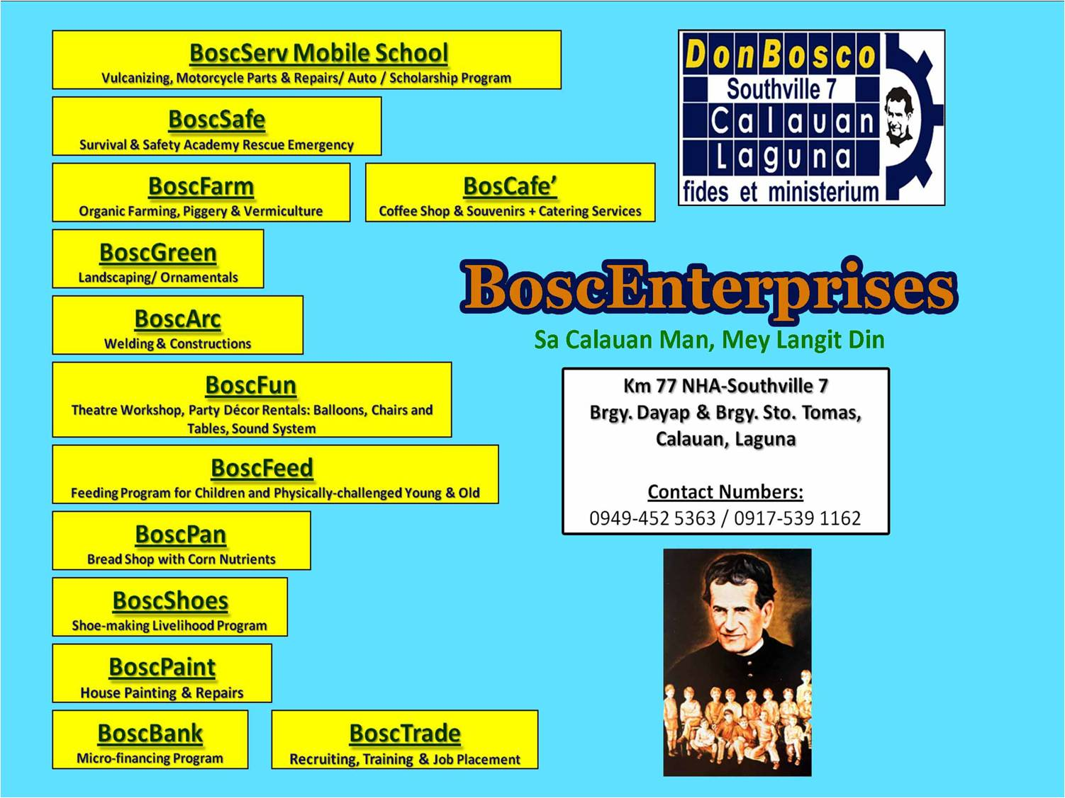

In setting up this company, we provide jobs for the people, hope for the future, unity for the family. Establishing these various departments, we find too an opportune time to interperse in all these income generating activities, human and spiritual formation plus Salesian Educational and Spiritual life and culture.

As of today, the following eight (8) departments are already functioning:

BoscSafe
BoscTrade
BoscFun
BoscNutri-Child Feeding Program
BoscArc / BoscPaint
BoscServe
BoscBread
BoscFarm

God willing, BoscShoes (shoe-making), BoscSeeds (a micro-financing department), BoscFudz (siomai & smoled-fish or tinapa making), BoscMeds (Pharmacy or Botika ng Bayan) are about to spin-off on the month of July: we pray. And soonest possible time will be the BoscCafe, Bosc Green. Again, God willing and blessing with our humble human toil and Salesian servant-leadership.

- Within the multi-cultural and multi-religious and poor contexts of East Asia: What contribution can religious awareness and sensitivity make? (Keep in mind traditional and new forms of religious experiences). What attitudes do you encounter among more marginalised people (because of culture, economic means, and moral life)?

Positive Attitudes
The Poor people we are with manifest the following positive attitudes:
- Sense of God and openness to the Spirit
- Versatility in looking for and accepting job offers and opportunities
- Search and longing for a better life
- Flexibility, patience in the daily toil of life: be it house chores, menial jobs and income generating activities

Attitudes needed to be Enhanced Among our Marginalized people
= to be more creative and enterprising people in daily chores and work
= to be more generous in giving and not only to expect the receiving end from benefactors
= to learn to serve the community with initiatives and industriousness
= to be one with the common vision-mission-goals of the bigger community
= to avoid myopic perspective and viewpoint, and thus to widen one’s horizon in community
Building
= to appreciate, respect and improve the environment and obtain a betters sense of ecological
Mentality

Within the multi-cultural and multi-religious and poor contexts of East Asia: What contribution can religious awareness and sensitivity make? (Keep in mind traditional and new forms of religious experiences).

The poor have a strong sense of God and a deep resignation in the daily events and undertakings in life. I find so much their faith in God. I believe they experience God in a wonderful way. We will surely be amazed to listen to their religious or God-filled experiences. As we are majority Catholics here in the Philippines, yet we have in our place here in Calauan, Laguna where I am currently assigned a few of Buddhists, Muslims, Protestants and others.

The Caritas Manila and the Diocese of San Pablo have introduced the faith-sharing to a few number of families when they were still doing the Pastoral Care to the Southville 7 Community, way back 2007. This Faith-sharing is based on the Basic Ecclesial Community (B.E.C.) spiritual program. This is a good ground for the in-depth or contribution to the religious awareness and sensitivity in a context like ours.

Faith sharing through an issue-concern based accompanied with Biblical passages, Bible Study and inspiration talks are all stepping-stones to a progress and deepening of the journey of faith of our people. Such will intensify religious awareness and sensitivity of the said community.

- Collect experiences and reflections emerging from your own context regarding the initial proclamation of Jesus, who was born, died and rose from the dead in West Asia, yet, even today, the Church remains «a little flock» in the whole Asian continent (Ecclesia in Asia, 1).

In answer to the above question, let me just share with you an article that I have written and have submitted to our Salesian Bulletin (FIN) last December 2010.

Here it goes:

Creative Ministries

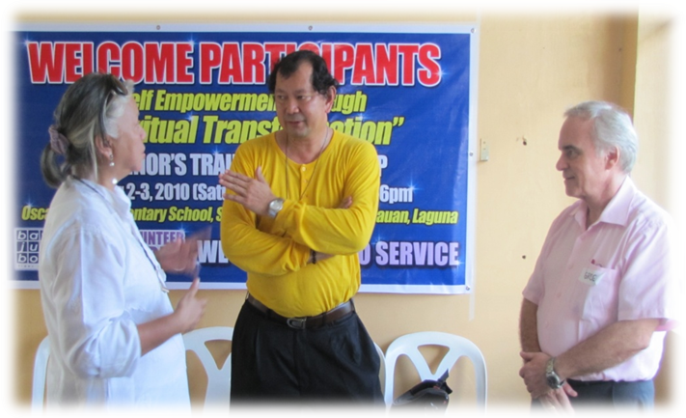
A seminar on Personal Empowerment through Spiritual Transformation organized by Ms. Carmen Prieto (L) and conducted by Canadian Mr. Greg Forbes (R) at the Southville 7 Calauan, Laguna. Fr. Pat Villasanta, SDB (center) was the Coordinator of the activity.

By Fr. Pat P. Villasanta, SDB
- A Salesian Priest of Don Bosco and
- a Graduate of the Masters in Social Services and Development
in the Asian Social Institute, Manila (May 2010)

Who is the poor person? Asian Social Institute (ASI) professor William Gois said that, more than being bereft of material blessings, “a poor person is one who has least or no opportunities/ options in life.” Sadly, for a man whose only skill is to drive a tricycle, there is no other option but to become a tricycle driver.

To help people rise above poverty, we need to broaden their horizons. At Don Bosco Southville 7 in Calauan, Laguna, this task entails applying St. John Bosco’s paradigm with a dash of 21st century Salesian creativity and at the same time an integration of the ASI’s goal which is ‘to form socially-oriented leaders… to uplift the marginalized sector of the society’.

NEW SALESIAN PRESENCE: Fr Salvador Pablo and I first came to Southville 7 in May 2010. The 107-hectare resettlement area now accommodates over 6,000 poor families from Metro Manila and Cavite, including informal settlers who used to reside along Pasig River.

This National Housing Authority (NHA) project is supported by various private companies and non-government organizations, such as the Diocese of San Pablo, Caritas de Manila, ABS-CBN Foundation, Inc. (AFI), San Miguel Corporation (SMC), Habitat for Humanity, Ayala Foundation and other stakeholders. Their efforts include housing as well as developmental projects to empower residents.

It was the Ayalas who thought of inviting the Salesians of Don Bosco to be involved. Looking at the demographics of Southville 7, it’s not hard to understand why. Based on an AFI survey, 52% of the population is below 18 years old. The largest age group, 22%, is composed of children ages 6 and below. And, with a rate of 10 births a week, they are growing exponentially!

When asked during a rectors’ meeting about our work in Calauan, Fr. Pablo gave a very Salesian response: “Bread, work and heaven. That’s our paradigm.” St. John Bosco’s promise to his children is the very same we hope to give at Don Bosco Southville 7, Calauan.

BREAD: Many of the residents are in a state of emergency, and are in dire need of food and proper nutrition. The AFI survey showed that 23% are unemployed and that those with income survive on meager salaries, with majority earning P9,000 (ca. $185.00) and below monthly.

We started getting food and clothing donations from the Salesian and Franciscan communities in Italy, as well as from confreres and friends in the country. Items ranging from rice to rubber slippers have been distributed to the hungry and underprivileged.

Soon to be launched is the BoscoBread project, which promises livelihood to bakers and vendors while at the same time offering affordable and nutritious bread enriched with corn.

Clearly, we can’t catechize young people with empty stomachs. But we can sacramentalize and nourish them at the same time. Every time we celebrate Holy Mass with the children, they are given reward points for attending. These points are added up and then exchanged for food and other gifts.

WORK: With only 7% able to find jobs in Calauan, there’s an urgency to help people market their current skills as well as train them to learn more.

Bosconians from Makati came in with a social mapping tool to help us assess the situation further. For example, we learned that residents have specific skills, such as baby-sitting and carpentry, which we can promote to those who require them in Metro Manila, thereby providing them with temp jobs at the least.

To widen their set of skills, friends and volunteers have offered various training sessions such as bread-making, drawing and painting, basic carpentry, vermi-culture and organic farming. Moreover, a number of young people are now taking up technical vocational courses at the Don Bosco Makati and Mandaluyong.

HEAVEN: As we strive to help provide their basic needs, we gradually open them up to experience God through activities ranging from the mundane to the sacred. The Yuppeace Movement and the Brothers from the Salesian Theologate Paranaque are one with us in organizing activities such as fun games and sports, bingo sessions, leadership seminars, the Sunday Oratory, the Eucharist and Confession, rosary rallies, and house blessings. With these, the residents discover the meaning and value of celebration and presence.

Even movie nights are occasions for fellowship. Three times a night, about 600 of them converge before the Mega Wall (i.e. a side wall of one house that we painted white and use as a movie screen). Armed with an LCD projector and 800-watt speakers, we entertain them with a selection of flicks while they line the street—some sitting, some flat on their backs, others craning their necks just inches from the screen.

Evidently, so much still needs to be done. As we broaden and improve our services, it is clear that, as Fr. Pablo so well put it, “our work here is a non-linear way of ministry.” With the great number of families, we can’t but provide as many options as possible. Indeed, our challenge is toward creative ministry in alleviating poverty through empowering the relocatee-families especially the young in the course of education and value-formation. Through this, we can help the young of Southville 7 tap the great potential they possess as we establish the Salesian Family Spirit and the ASI way of bringing development, growth and meaningfulness in the people’s lives.

